Ideation Phase
Brainstorm & Idea Prioritization Template

Date | 31 January 2025
Team ID | LTVIP2026TMIDS65560
Project Name | Educational Organization Using Servicenow
Maximum Marks | 4 Marks

Brainstorm & Idea Prioritization Template:
Brainstorming provides a free and open environment that encourages everyone within a team to participate in the creative thinking process that leads to problem solving. Prioritizing volume over value, out-of-the-box ideas are welcome and built upon, and all participants are encouraged to collaborate, helping each other develop a rich amount of creative solutions. Use this template in your own brainstorming sessions so your team can unleash their imagination and start shaping concepts even if you're not sitting in the same room. Reference: https://www.mural.co/templates/brainstorm-and-idea-prioritization
Step-1: Team Gathering, Collaboration and Select the Problem Statement
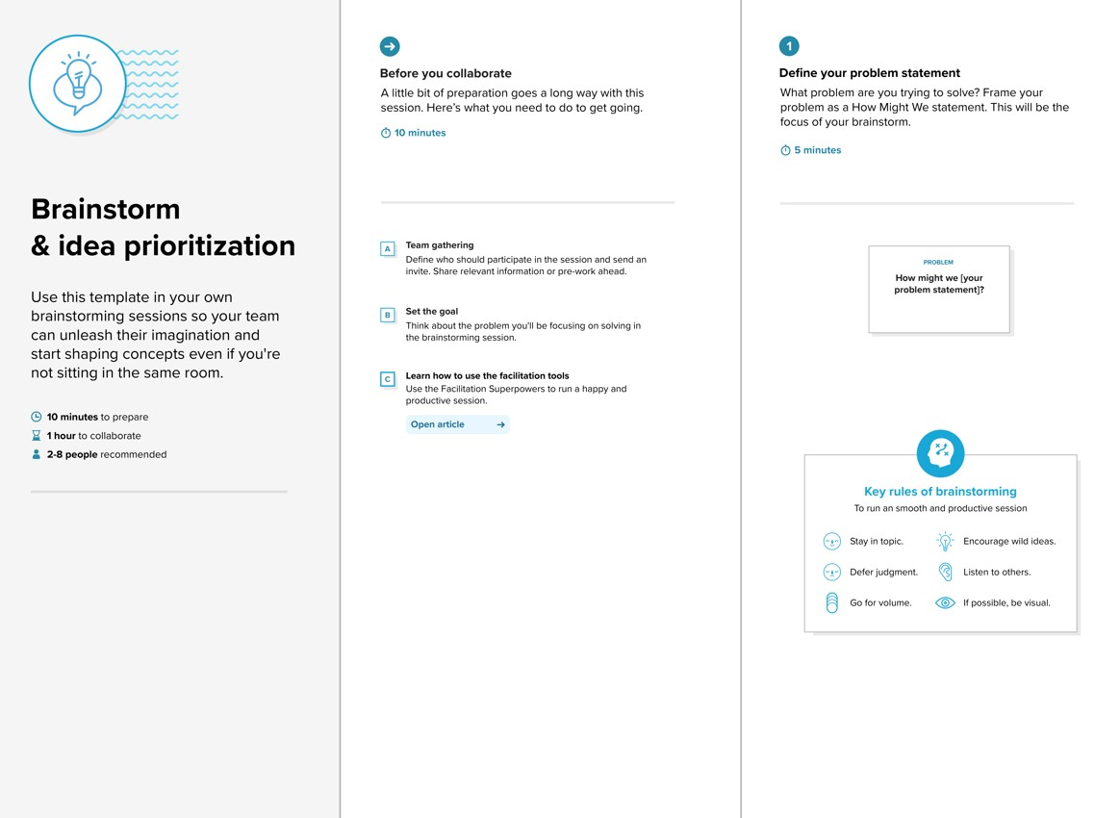

Step-2: Brainstorm, Idea Listing and Grouping
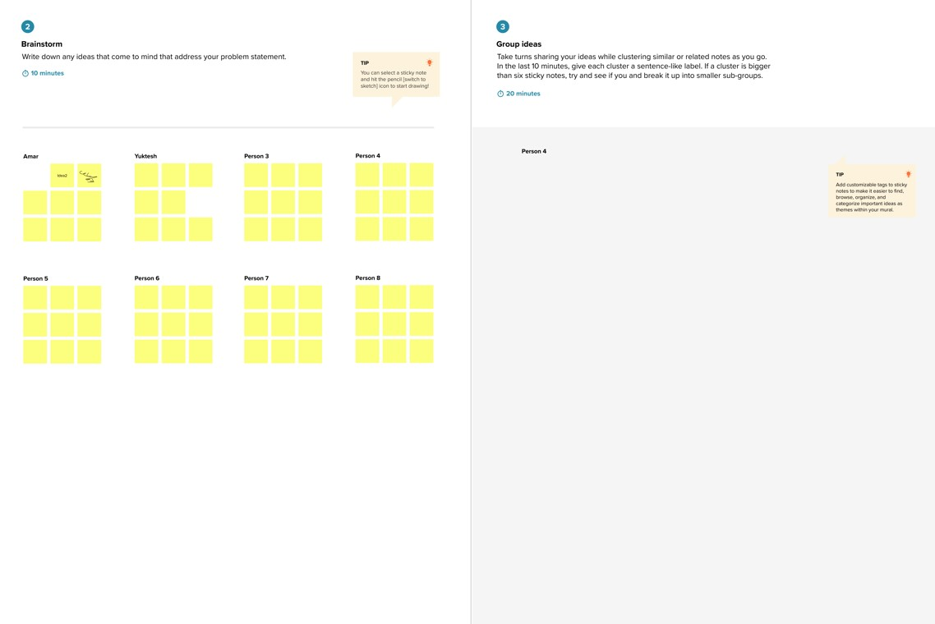

Step-3: Idea Prioritization
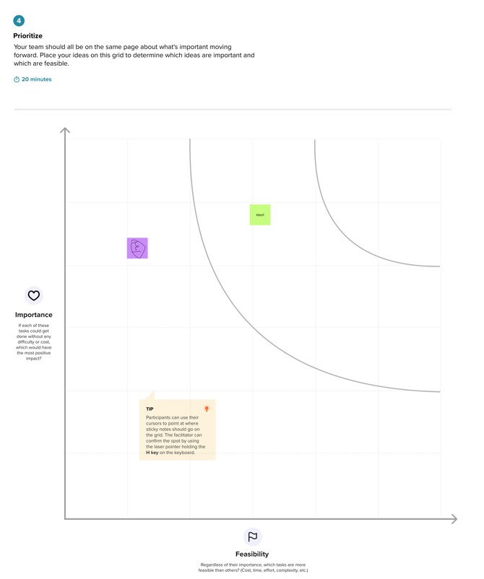
Step 1: Team Gathering, Collaboration, and Problem Statement Selection
- All five team members gathered virtually to initiate ideation on possible realworld problems that can be solved using low-code platforms.
- After evaluating common administrative inefficiencies in schools, the team chose the problem statement:
“How might we automate student admissions and academic performance tracking in educational institutions using ServiceNow?” Step 2: Brainstorming, Idea Listing, and Grouping
Raw Ideas Collected:
- Auto-generation of admin number
- Digital admission form
- Auto-fill form data from existing tables
- Pincode-based area detection
- Auto-calculation of student total & percentage
- Visual status flow of admission
- Parent contact tracking
- Conditional form field disabling
- Role-based access control
- Cloud-access from anywhere
- Automate result declaration
- Quick reporting system
- Future integration with email/SMS notifications
Grouped Ideas:
- Admissions Automation
- Auto-generated admin number
- Pre-filled form fields
- School & purpose selection
- Performance Tracking
- Subject marks input
- Auto calculation of total, percentage, result
- Workflow & UX
- Status-based flow
- Field disabling for safety
- Area update using pincode
- Scalability
- Role-based access
- Notifications
- Reporting features
Step 3: Idea Prioritization
Idea Group Priority Reason for Priority
Admissions
Automation High Core to system functionality, reduces time
Performance
Tracking High Automates academic evaluation, boosts accuracy
Workflow & UX Medium Enhances usability, but can be improved later
Scalability Features Low Useful in future scope, not immediate MVP need

